North Korea Fires Ballistic Missiles as US Aircraft Carrier Returns to Peninsula
随着美国航空母舰返回半岛，朝鲜发射弹道导弹
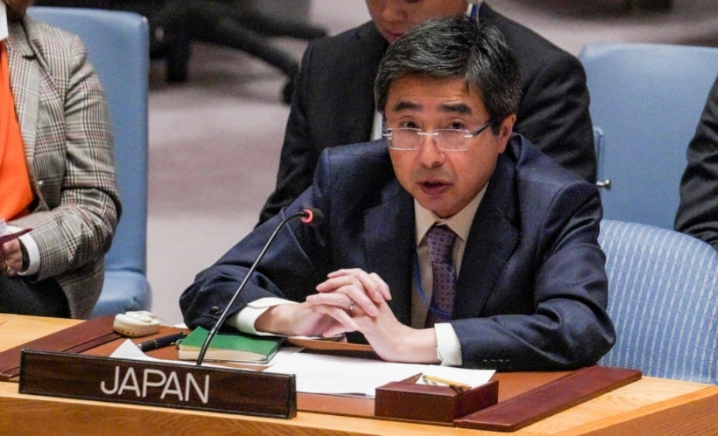
SEOUL, SOUTH KOREA —
韩国首尔——
North Korea fired two more short-range ballistic missiles (SRBM) early Thursday, just two days after launching its longest-flying ballistic missile over Japan, angering regional leaders and the international community.
朝鲜周四早些时候又发射了两枚短程弹道导弹 (SRBM)，这距离其在日本上空发射其飞行时间最长的弹道导弹仅两天，这激怒了地区领导人和国际社会。

South Korea’s Joint Chiefs of Staff (JCS) said the SRBMs were launched between 6:01 a.m. and 6:23 a.m. from North Korea’s Samcheok area in Pyongyang into the East Sea. Their flight distance was between 350 to 800 kilometers, and their altitude between 60 and 80 kilometers.
韩国参谋长联席会议 (JCS) 表示，SRBM 于上午 6 点 01 分至 6 点 23 分从朝鲜平壤三陟地区发射到东海。他们的飞行距离在 350 到 800 公里之间，高度在 60 到 80 公里之间。

The missile launch marks the sixth in 12 days and comes one day after the USS Ronald Reagan supercarrier was rerouted back to the Korean Peninsula after last week's naval drills, which were part of maneuvers to pressure North Korea against additional provocations.
导弹发射标志着 12 天内的第六次发射，并且是在美国罗纳德·里根号超级航母改道回航后的一天。朝鲜半岛在上周的海军演习之后，这是向朝鲜施压以反对进一步挑衅的演习的一部分。

Japanese Prime Minister Fumio Kishida said the volley of missile fire in recent days was “absolutely unacceptable.”
日本首相岸田文雄表示，最近几天的导弹齐射“绝对不能接受”。
The latest missile likely flew in an “irregular trajectory,” Defense Minister Yasukazu Hamada said on Thursday, reiterating that “these actions by North Korea are a threat to peace and security of [Japan], [the] region and the international community.”
防卫大臣滨田康和周四表示，最新的导弹可能以“不规则轨迹”飞行，并重申“朝鲜的这些行动是对[日本]、[该]地区和国际社会的和平与安全的威胁。”

Prime Minister Kishida and South Korean President Yoon Suk Yeol are to speak by phone later Thursday.
岸田总理和韩国总统尹锡烈将由周四晚些时候打电话。

North Korea breaks silence
朝鲜打破沉默

In its first commentary since firing a ballistic missile over Japan, North Korea indicated the missile launch was a reaction to recent moves by the United States, accusing the U.S. of “posing a serious threat to stability” in the region by redeploying the USS Ronald Reagan to the Korean Peninsula.
朝鲜在发射弹道导弹飞越日本后的首次评论中表示，导弹发射是对美国近期行动的反应，指责美国“构成严重威胁”

North Korea's foreign ministry issued a brief statement, carried by North Korean state media, on Thursday “strongly condemning” the U.S. and some of its “satellites” for “unwarrantedly referring [North Korea] to the U.N. Security Council [for] the just counteraction measures of the Korean People’s Army against South Korea-U.S. joint drills escalating military tensions on the Korean peninsula.”
朝鲜外交部周四发表了由朝鲜官方媒体报道的简短声明，“强烈谴责”美国和它的一些“卫星”“无端地将[朝鲜]提交给联合国安理会[以]朝鲜人民军对韩美的公正反制措施。联合演习加剧了朝鲜半岛的军事紧张局势。”

The Nimitz-class aircraft carrier had returned to South Korea about 8 p.m. Wednesday, President Yoon told reporters. The rare decision to redeploy the carrier was one jointly made by the U.S. and South Korean militaries after North Korea’s provocative missile test on Tuesday, JCS said.
尼米兹级航空母舰已于晚上 8 点左右返回韩国。周三，尹总统告诉记者。 JCS 表示，重新部署航母的罕见决定是美国和韩国军方在朝鲜周二进行挑衅性导弹试验后共同做出的决定。

While the presence of supercarriers like the USS Ronald Reagan in the past had struck fear in Pyongyang, North Korea has become emboldened.
虽然像罗纳德·里根号这样的超级航母在过去让平壤感到恐惧，朝鲜变得更加胆大妄为。

That North Korea last week fired ballistic missiles into the East Sea while a major naval exercise featuring a U.S. supercarrier was going on is without precedent, points out Park Won-gon, North Korean Studies professor at Ewha Womans University.
朝鲜上周在以美国超级航母为特色的大型海军演习期间向东海发射弹道导弹，这是史无前例的，点out Park Won-gon，梨花女子大学朝鲜学教授。
“The international environment and world politics right now is very favorable to North Korea, and North Korea has not missed this chance to develop their nuclear weapon,” Park said. “And their final goal, of course, is to be recognized by the international community as a de facto nuclear weapons state.”
“现在的国际环境和世界政治对朝鲜非常有利，朝鲜没有错过这个发展核武器的机会，”朴槿惠说。 “当然，他们的最终目标是被国际社会承认为事实上的核武器国家。”

